**CST-323 Design Report**

|  |  |  |
| --- | --- | --- |
| **Topic:** | Activity 4 | |
| **Date:** | 2/16/20 | |
| **Revision:** | 1.0 | |
| **Team:** | 1. Ali Cooper | |
| 1. Anthony Natividad (worked on the project from 341) | |
|  | |
|  | |
| **Weekly Team Status Summary:** | |  |  |  |  | | --- | --- | --- | --- | | **User Story** | **Team**  **Member** | **Hours**  **Worked** | **Hours Remaining** | |  |  |  |  | |  |  |  |  | |  |  |  |  | |  |  |  |  | |  |  |  |  | |  |  |  |  | |  |  |  |  | |  |  |  |  | |  |  |  |  | |  |  |  |  | |  |  |  |  | |  |  |  |  | |  |  |  |  | | |
| **GIT URL:** | https://github.com/n4n0byte/cloudclcactivity.git | |
| **Peer Review:** | *Y* | We acknowledge that our team has reviewed this report and we agree to the approach we are all taking. |
| **Screen Cast** | <https://www.loom.com/share/a4333f4827444b7eac4c0d9e459d8a54> | |

**Planning & Design Documentation**

**Billing Reports:**

AWS Billing:

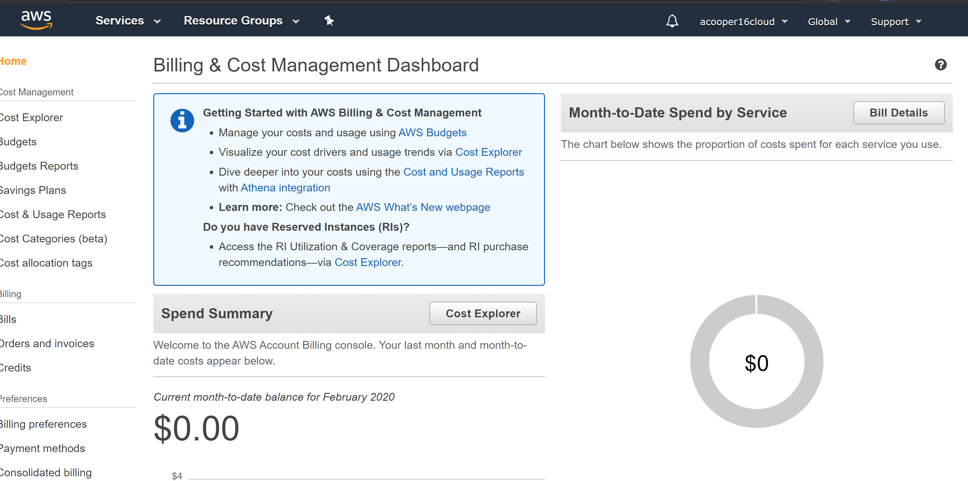

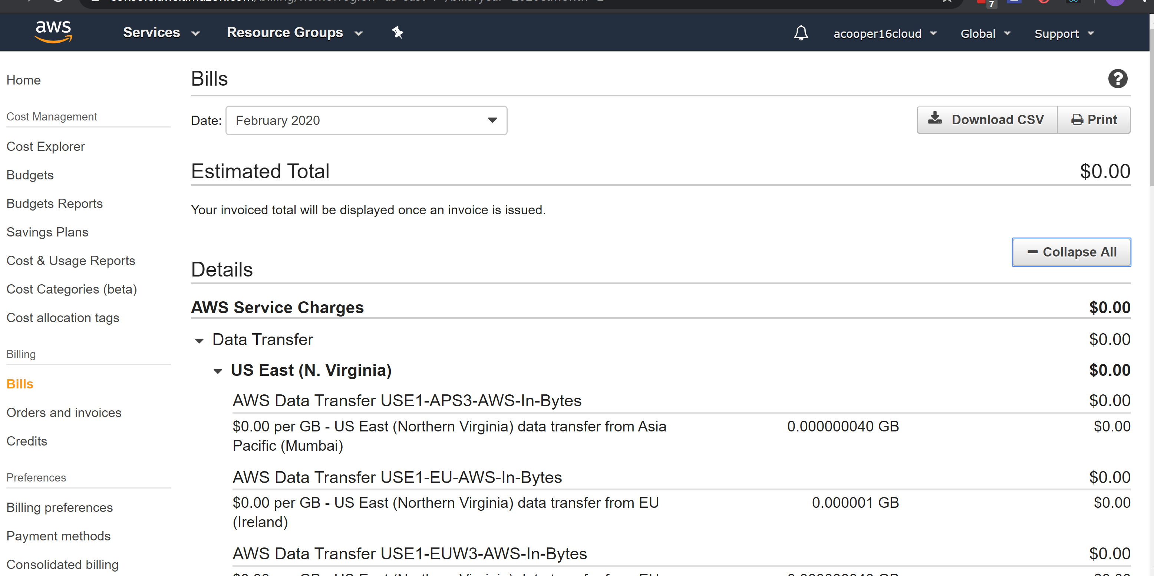

Gcloud Billing:

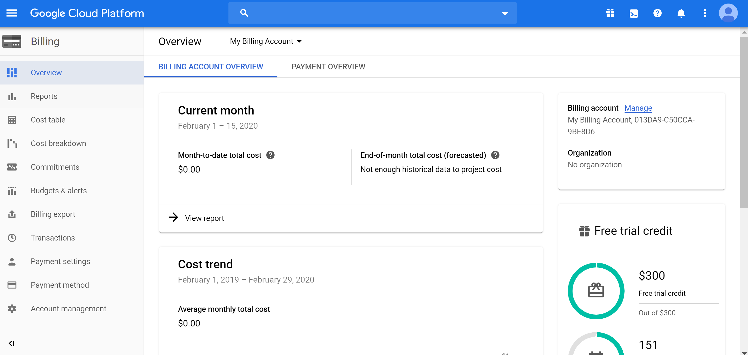

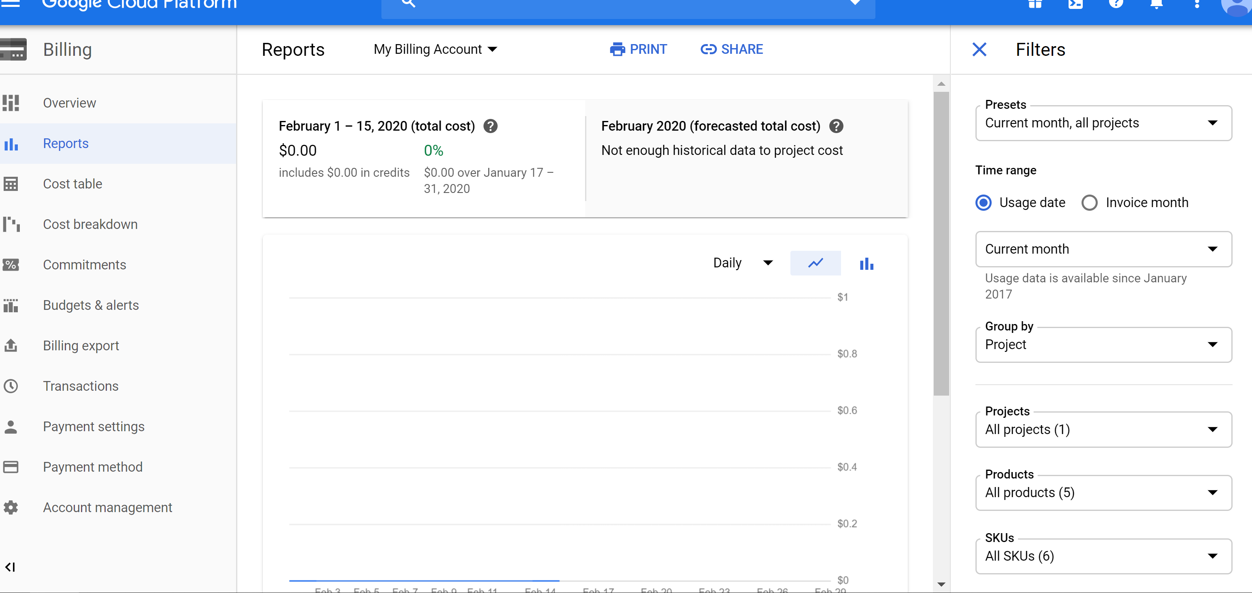

**Dependencies & Versions:**

Dependencies used on Google Cloud

* AppEngine Maven Plugin v1.3.1
* Google-api-client v1.21.0
* Google-api-client-appengine v1.21.0
* Spring Framework v4.3.9
* Apache Tiles v3.0.7
* Tiles-JSP v3.0.7
* Servlet API v2.3
* Jstl v1.2
* Hibernate Validator v6.0.4
* MySql-Connector-Java 8.0.19
* MySql-Socket-Factory-connector-j-8 v1.0.15

GCloud pom:

Dependencies used on AWS

* Spring Framework v5.2.3
* Apache Tiles v3.0.7
* Tiles-JSP v3.0.7
* Servlet API v2.3
* Jstl v1.2
* Hibernate Validator v6.0.4
* MySql-Connector-Java 8.0.19

AWS pom:



**Challenges:**

* Google Cloud
  + Appengine:run/deploy failed: fixed by replacing pom with one that was known to run mvn package correctly
  + Exception happened because models required the serializable annotation: fixed by adding said annotation
  + Assets not being served: fixed by moving webcontent resources directory to /webcontent
  + DB Errors
    - Unable to create connection: needed to use the correct MySQL connectors
  + Project wasn’t recognized as being able to be deployed to standard environment: fixed by adding appengine-web.xml
* AWS
  + Assets were not showing: this was fixed by moving resources directory to /webcontent and also upgrading spring to 5.2.3 and using the addResourceHandlers method
  + DAO’s not getting injected: fixed by setting the component scan to the correct base package (“com”)
  + No SSL: unresolved
  + Collation settings were incompatible: fixed by removing them and using the default on RDS

**Install, Config & Deployment Instructions:**

**DB**

AWS RDS MySql DB:

* 1. Login to AWS acct
  2. Select RDS
  3. 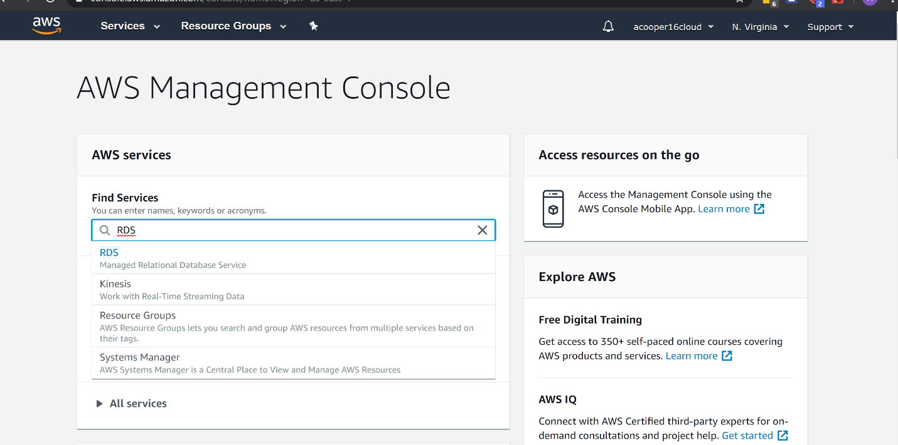

1. Scroll Down, click Create Database
   * 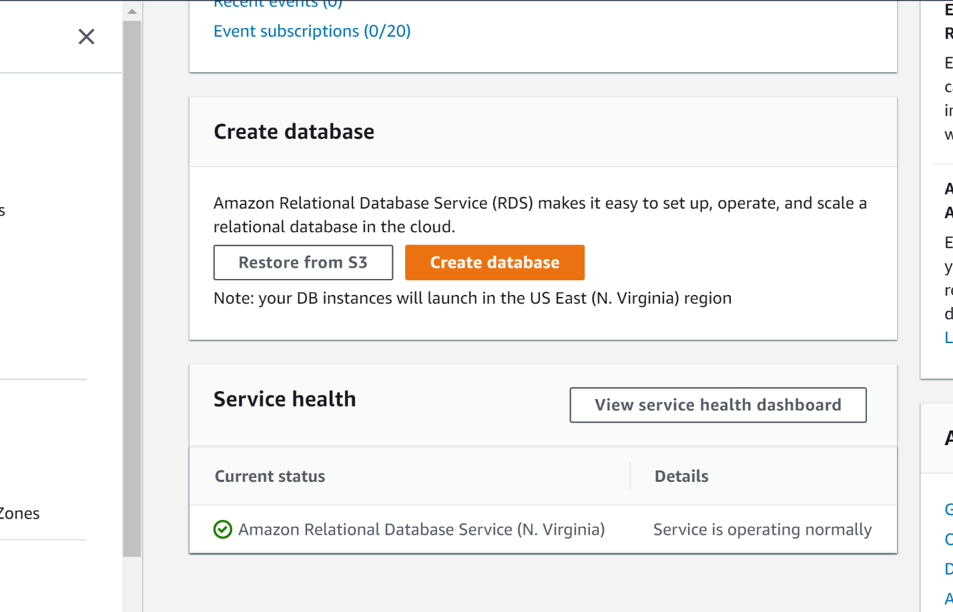
2. Create RDS
   * Select MySql 5.7S
   * 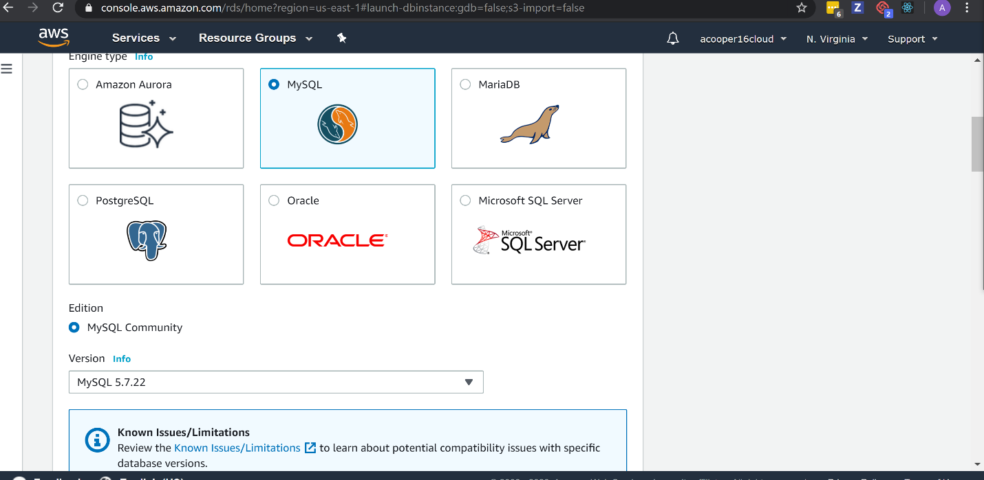
   * Select Free Tier
   * Setup credentials under credential settings
   * Go to connectivity > Additional connectivity dropdown
   * Set publicly accessible to 'yes'
   * 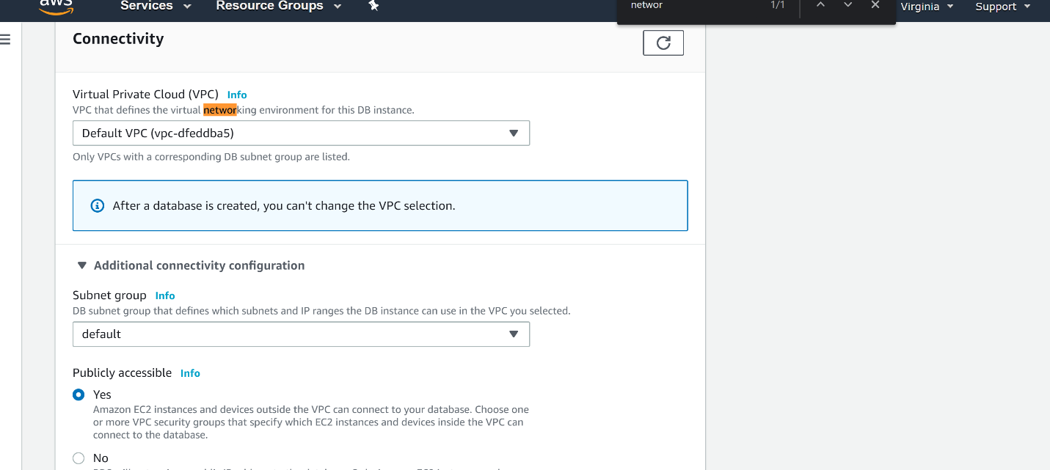
   * Create DB
   * 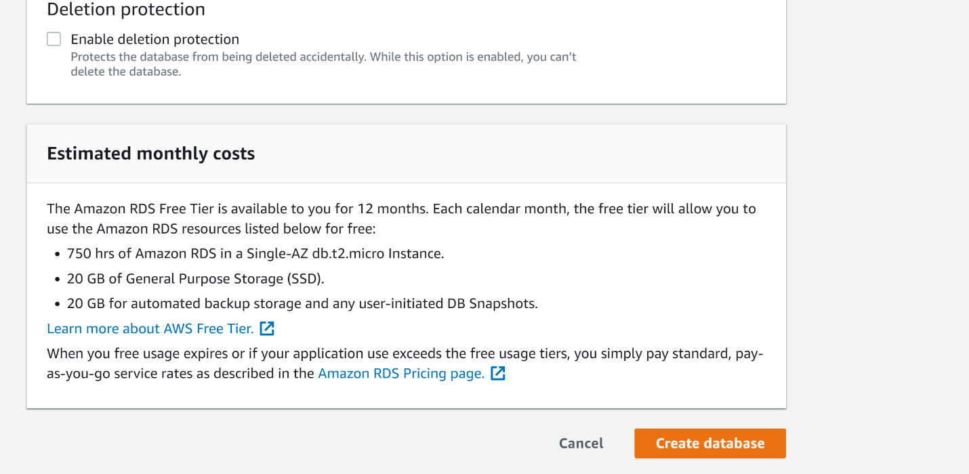
   * Wait for it to finish being created
   * 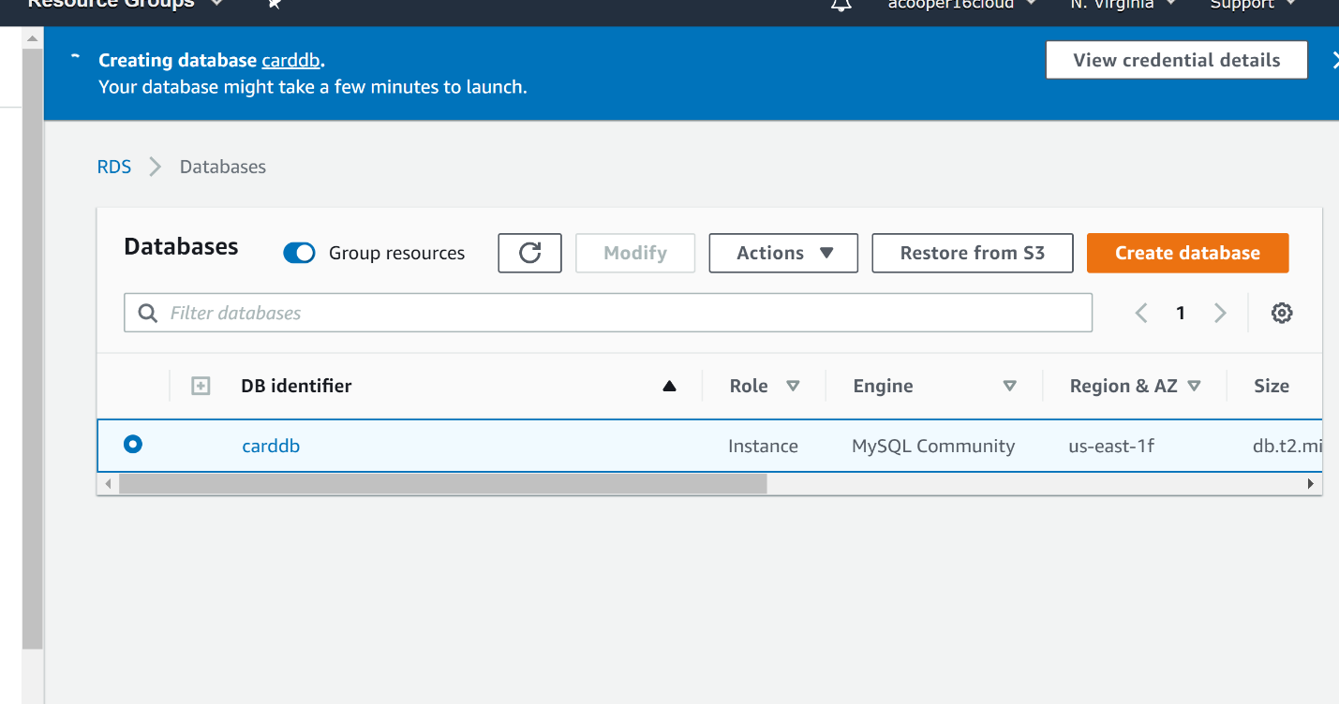
   * Go to connectivity & Security
     + Click the link directly under VPC Security Groups
     + 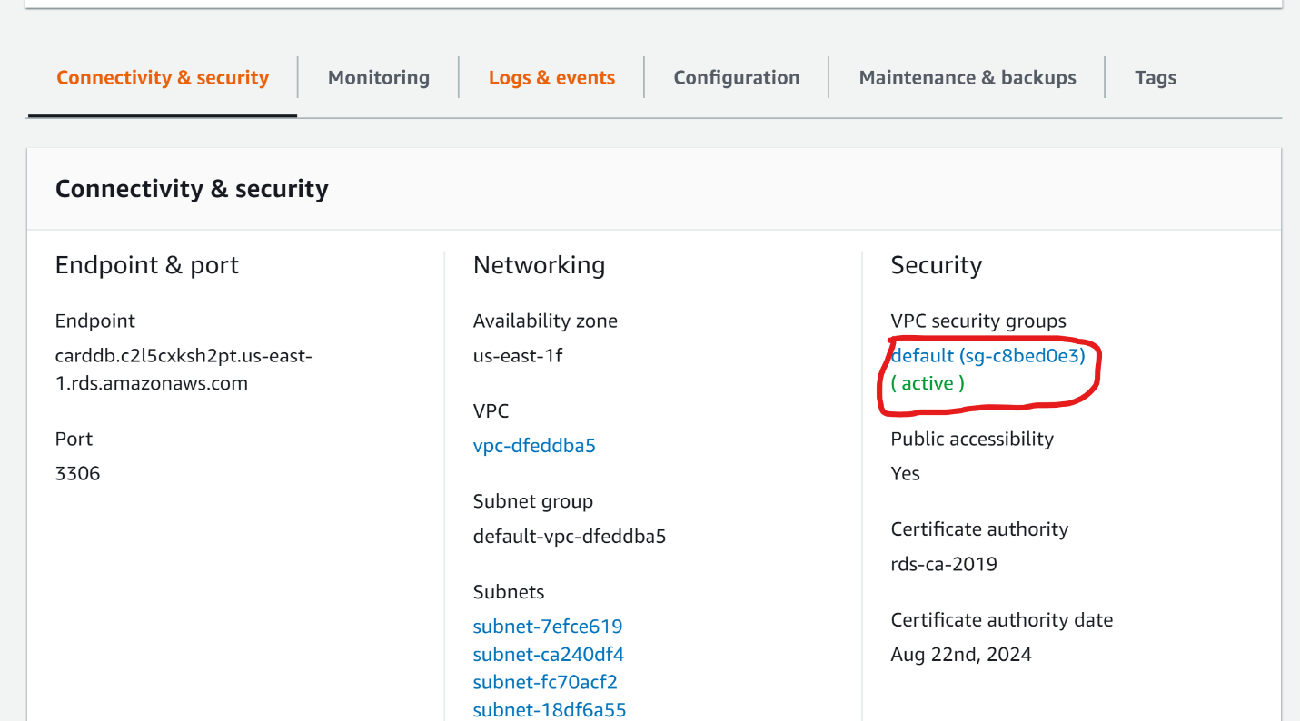
     + Click Inbound
     + 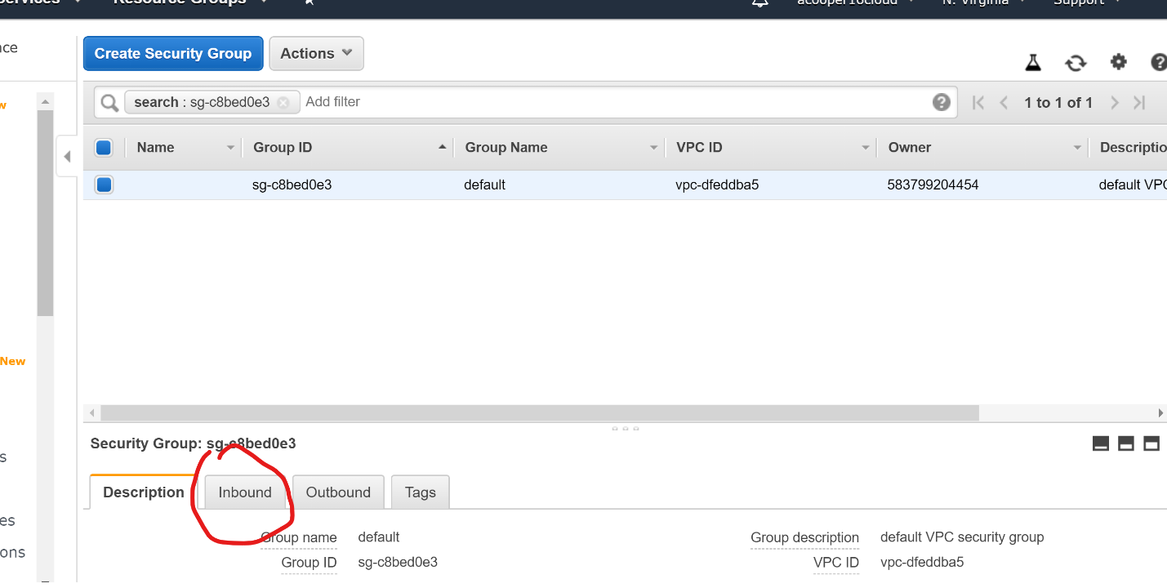
     + Edit
     + 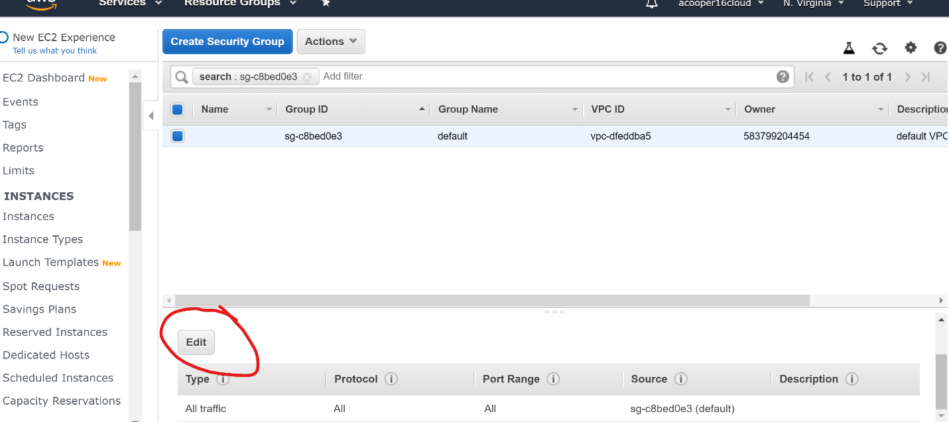
     + Select anywhere than save
     + 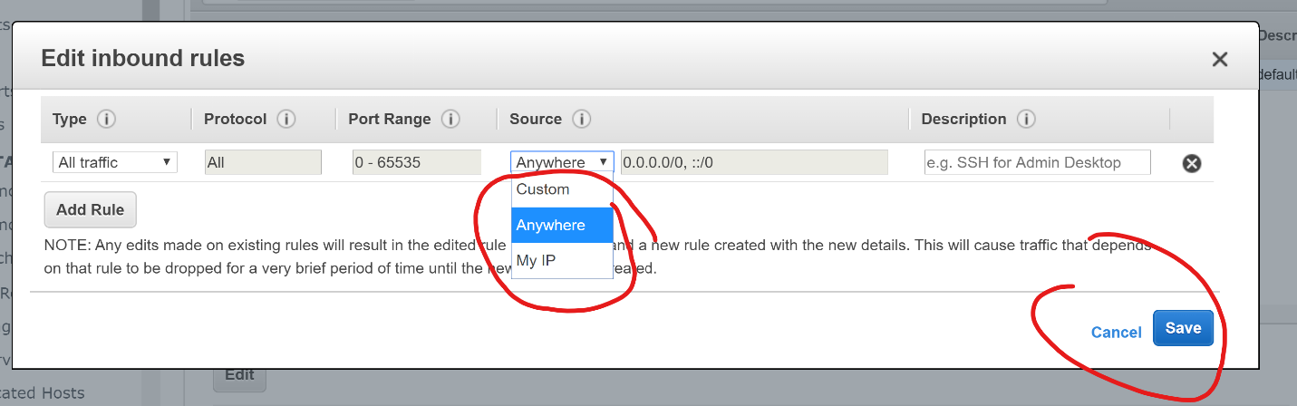
   * Connect to db using the server address listed directly under “Endpoint”
     + “carddb.c2l5cxksh2pt.us-east-1.rds.amazonaws.com” for me
   * Create a connection to the db in mysql workbench
   * Connect to it with given credentials
   * 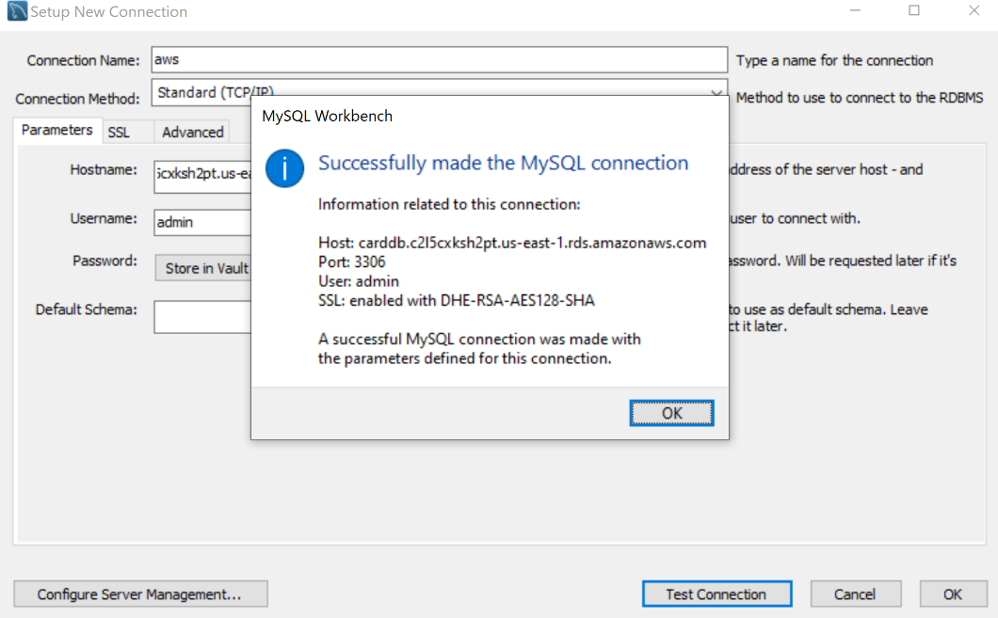
   * Forward engineer model/execute sql script

Google Cloud MySql DB:

* + Click SQL
  + 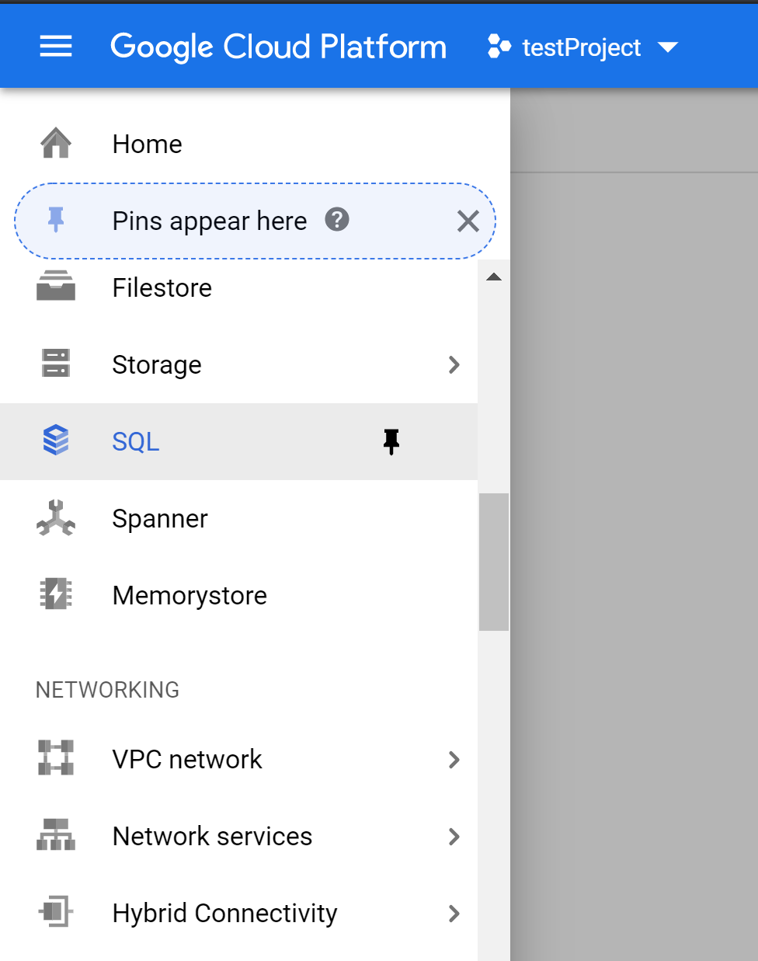
  + Click “Create instance”
  + 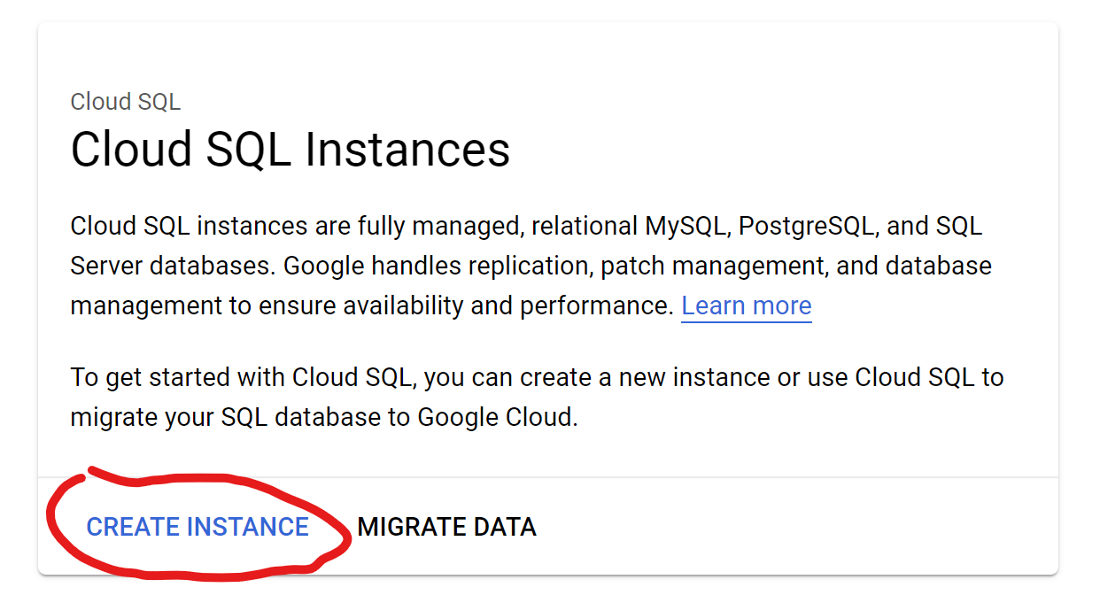
  + Click “Choose MySql”

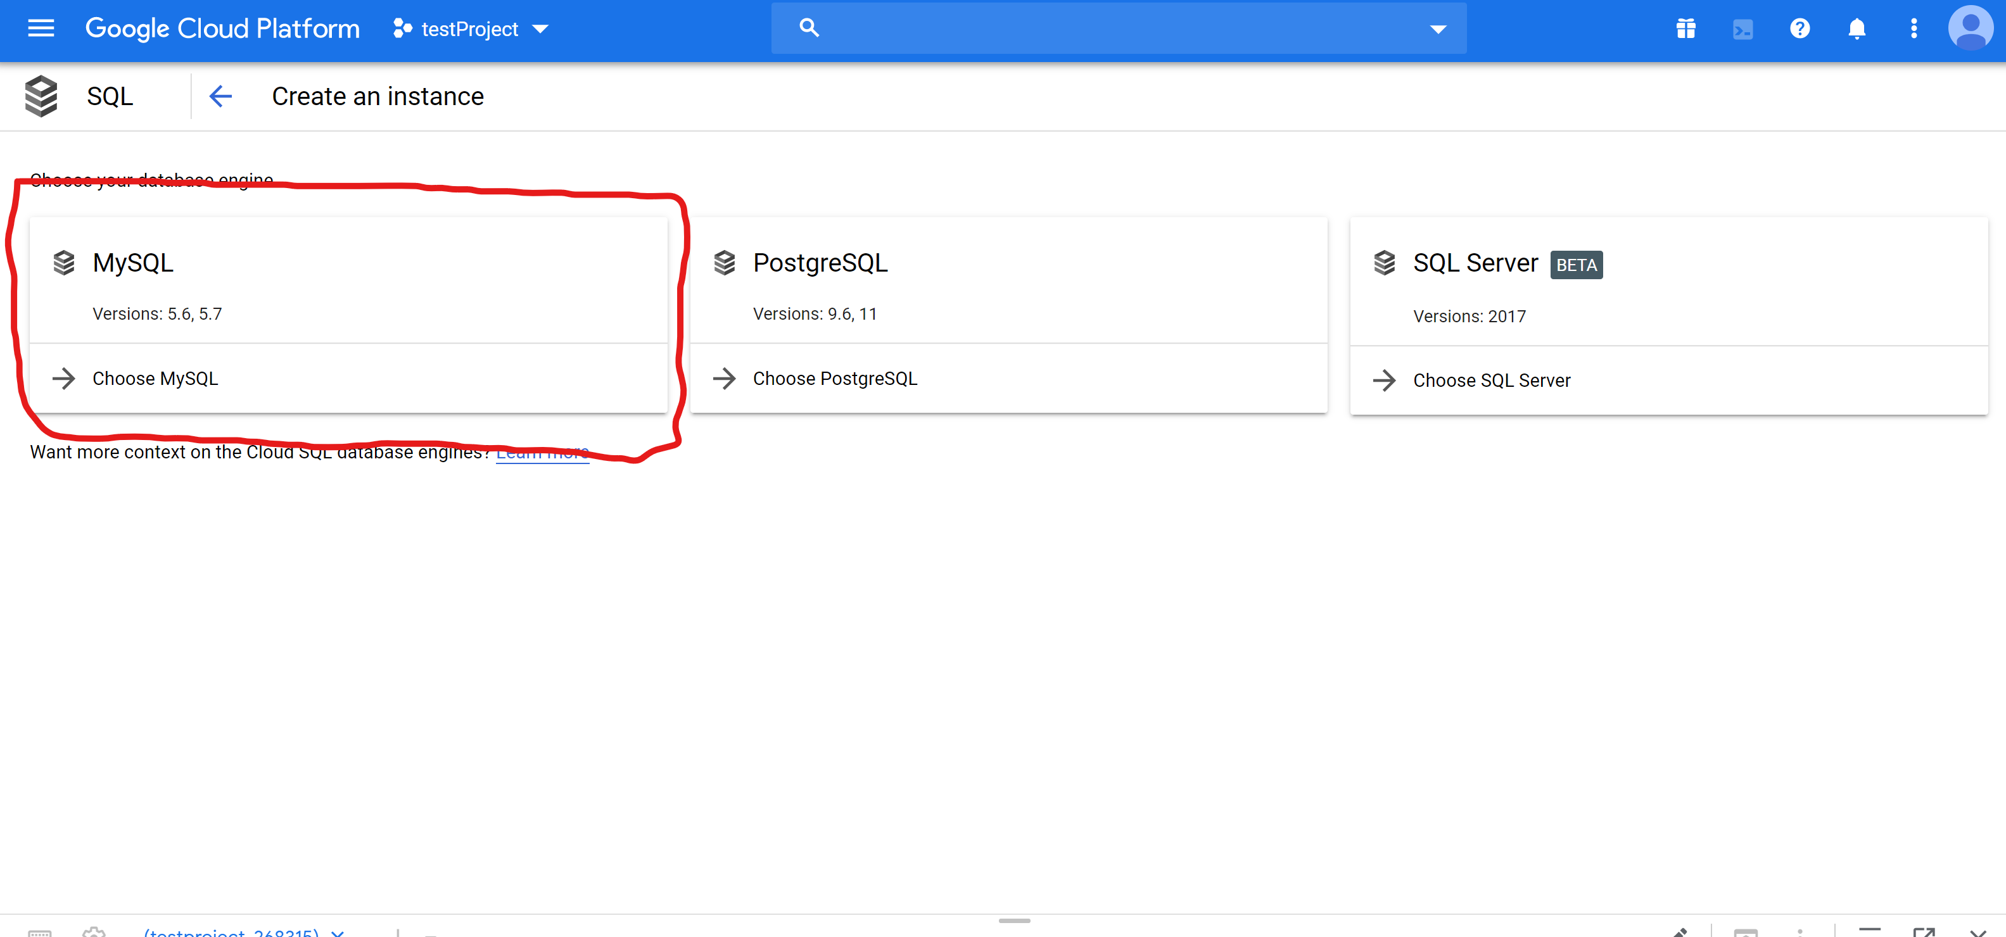

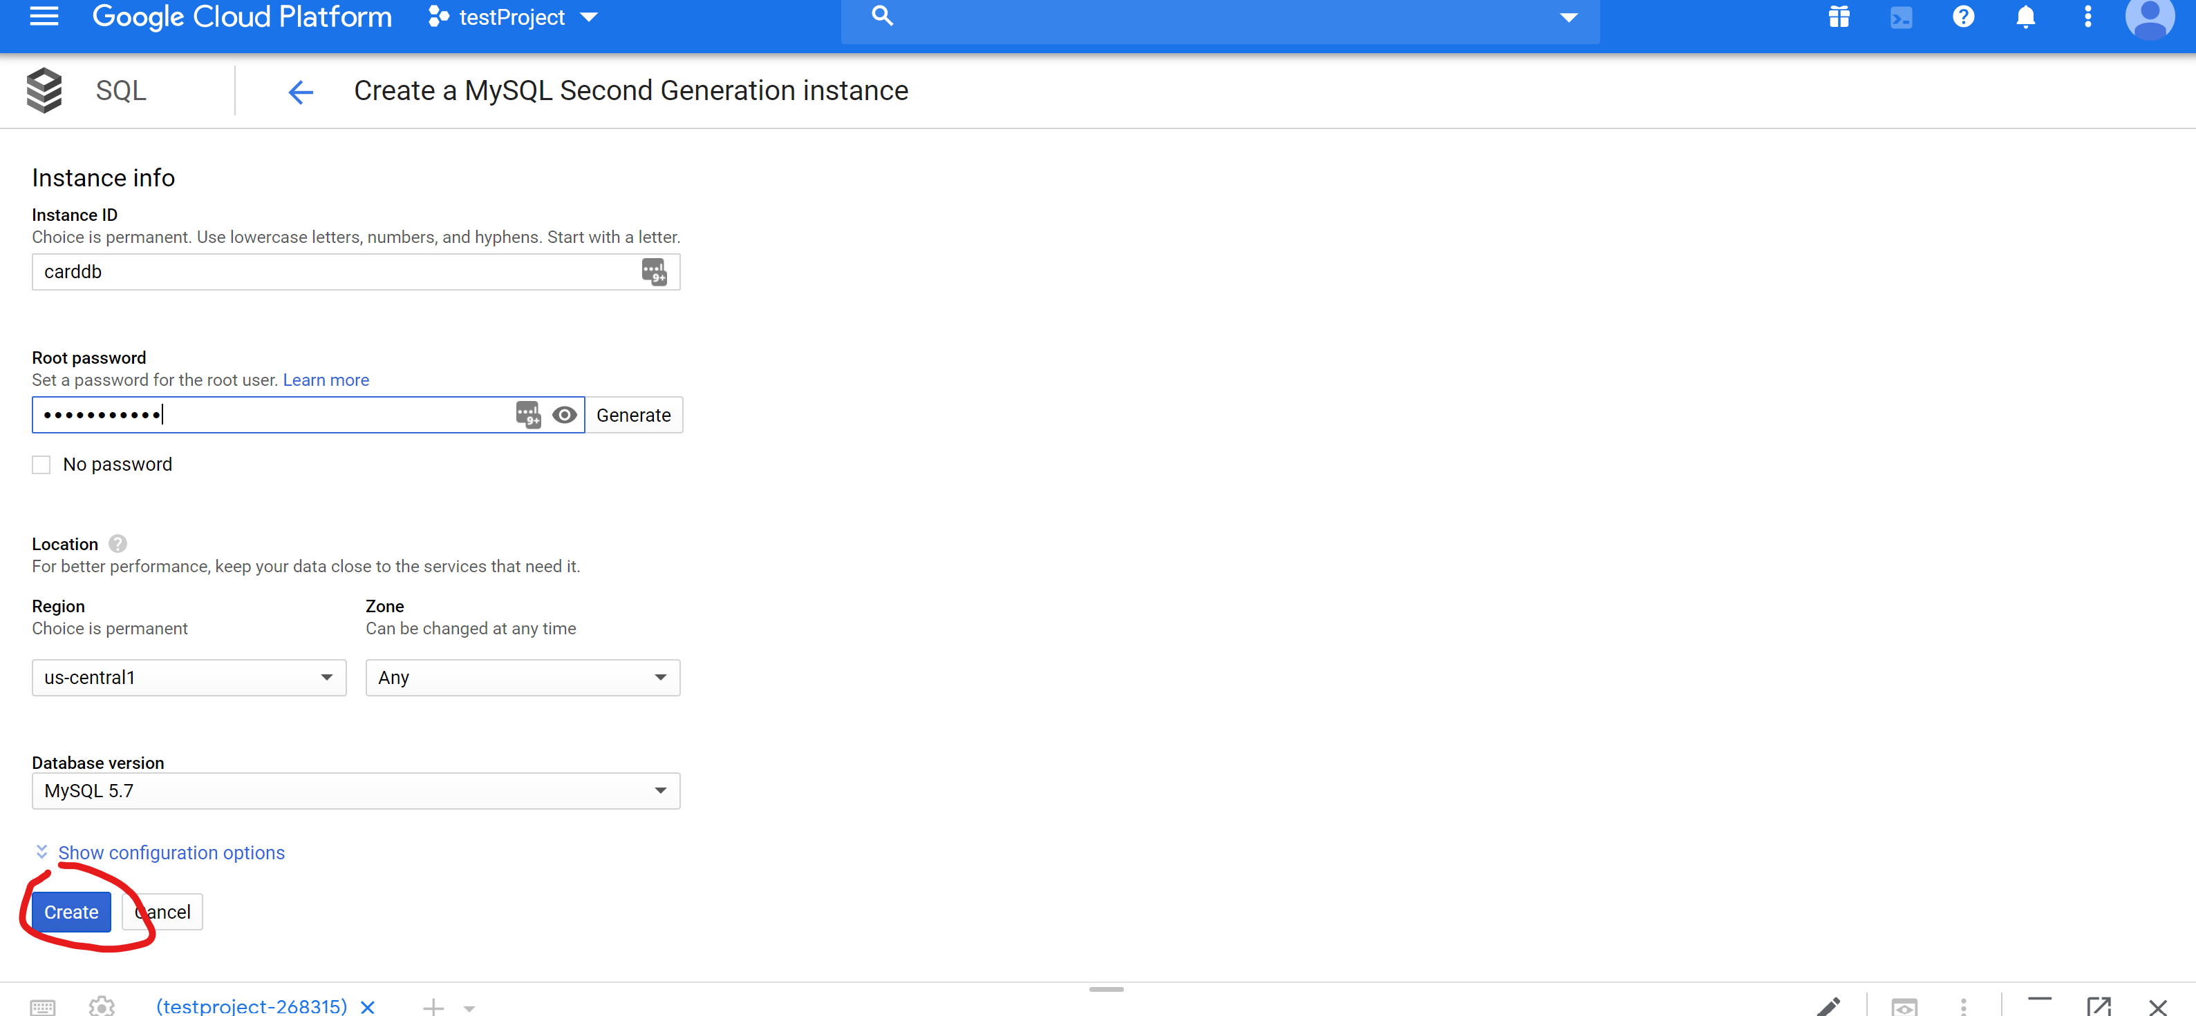

* + Name it and press create
  + Wait for it to be created
  + 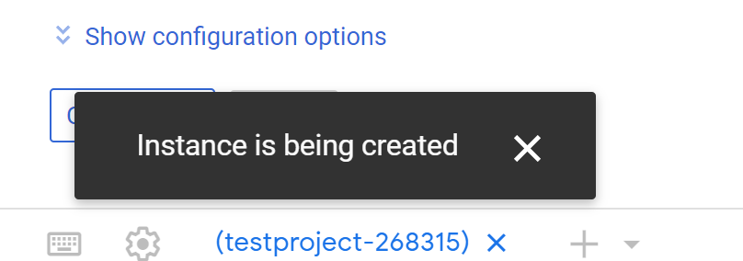
  + Go to users > create
  + 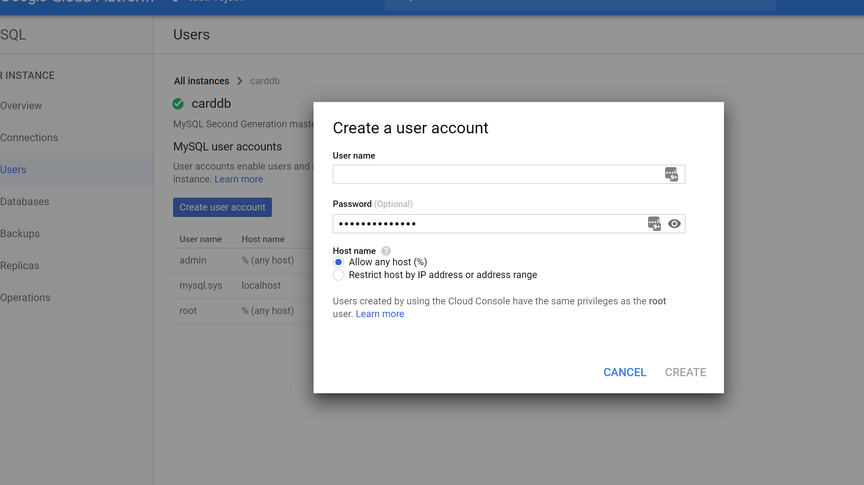
  + Fill in credentials > click create
  + Go to Connections > Authorized networks > add network
  + 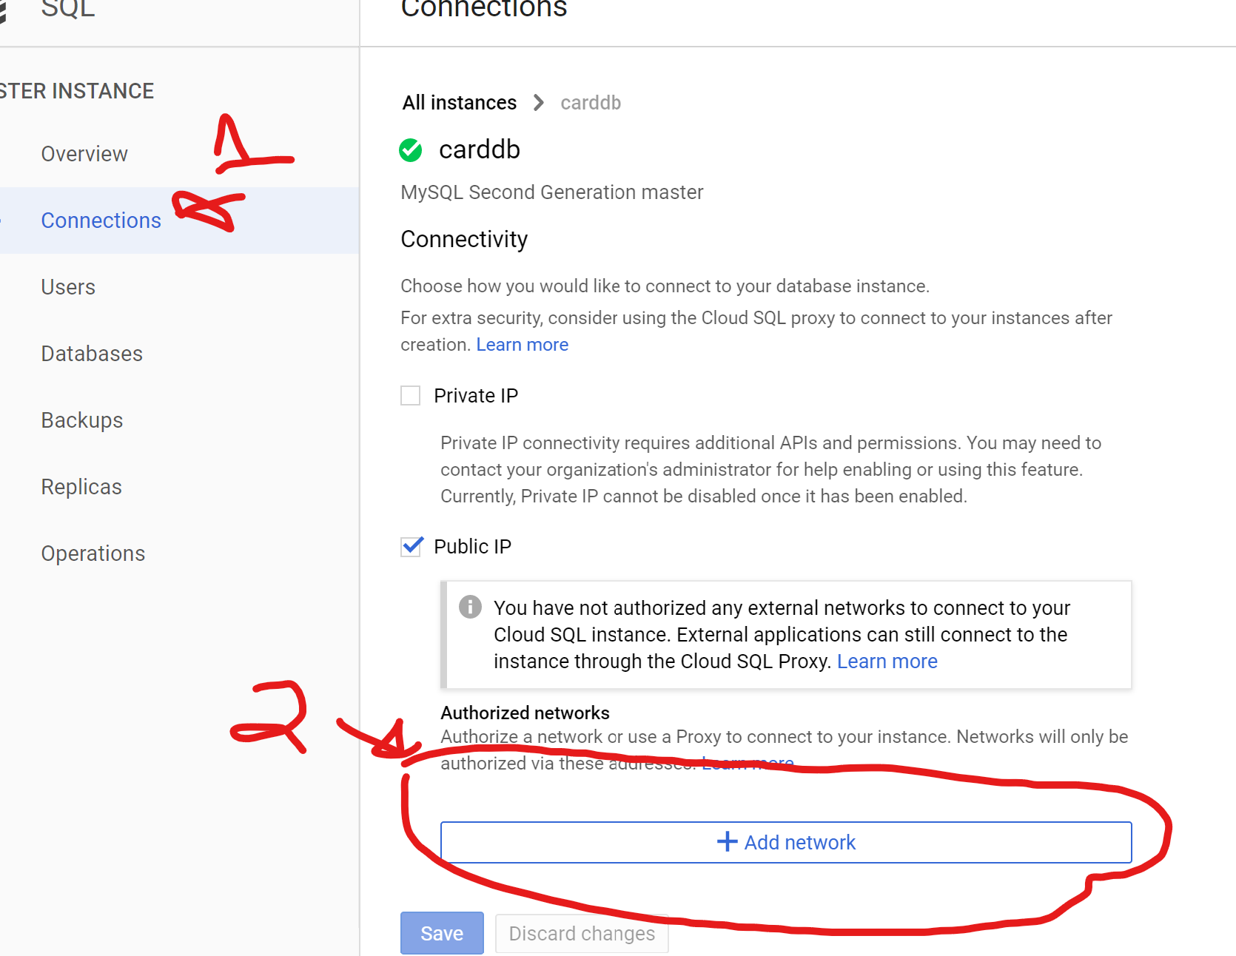
  + Get public ip (type “public ip “into google)
  + Click done > save
  + 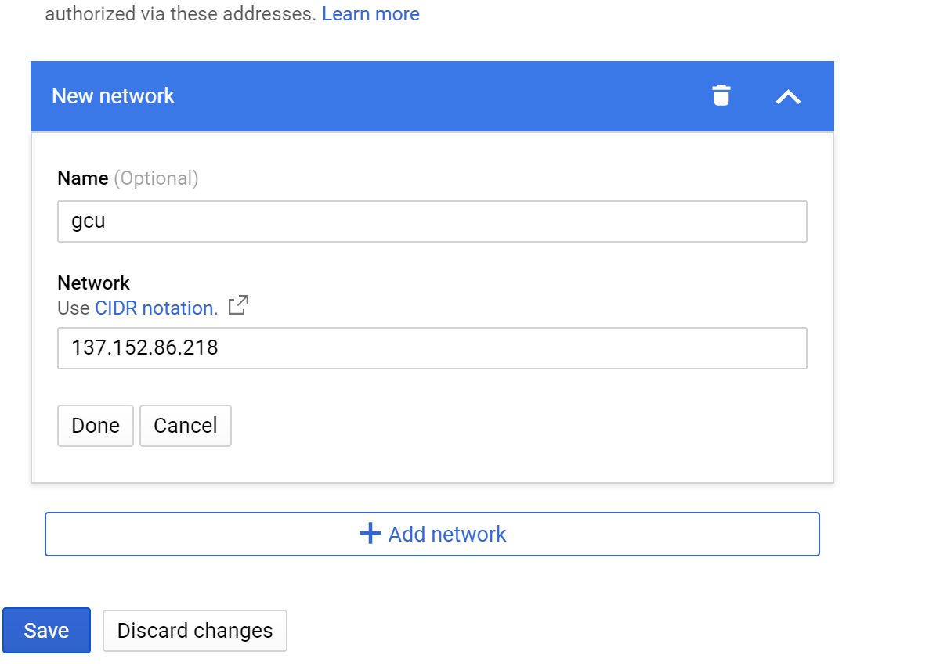
  + Connect using MySql Workbench
  + Run ddl script
  + 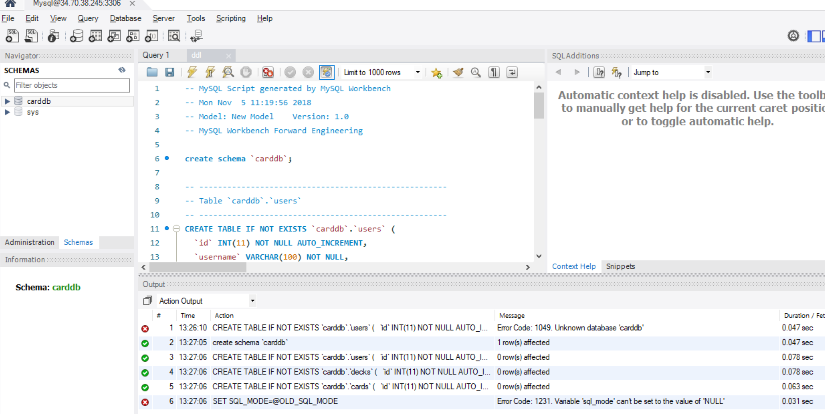

DDL Script:



**Project Preparation and Deployment:**

AWS Project Configuration:

* + Ensure that the correct pom.xml is in place (either with the pom embedded or with the changed mentioned above)
  + Update applicationConfiguration.xml with new credentials and server address
  + Move the /WebContent/WEB-INF/resources directory into /WebContent temporarily (for the deployment only)
  + Right click project -> export -> war file
  + 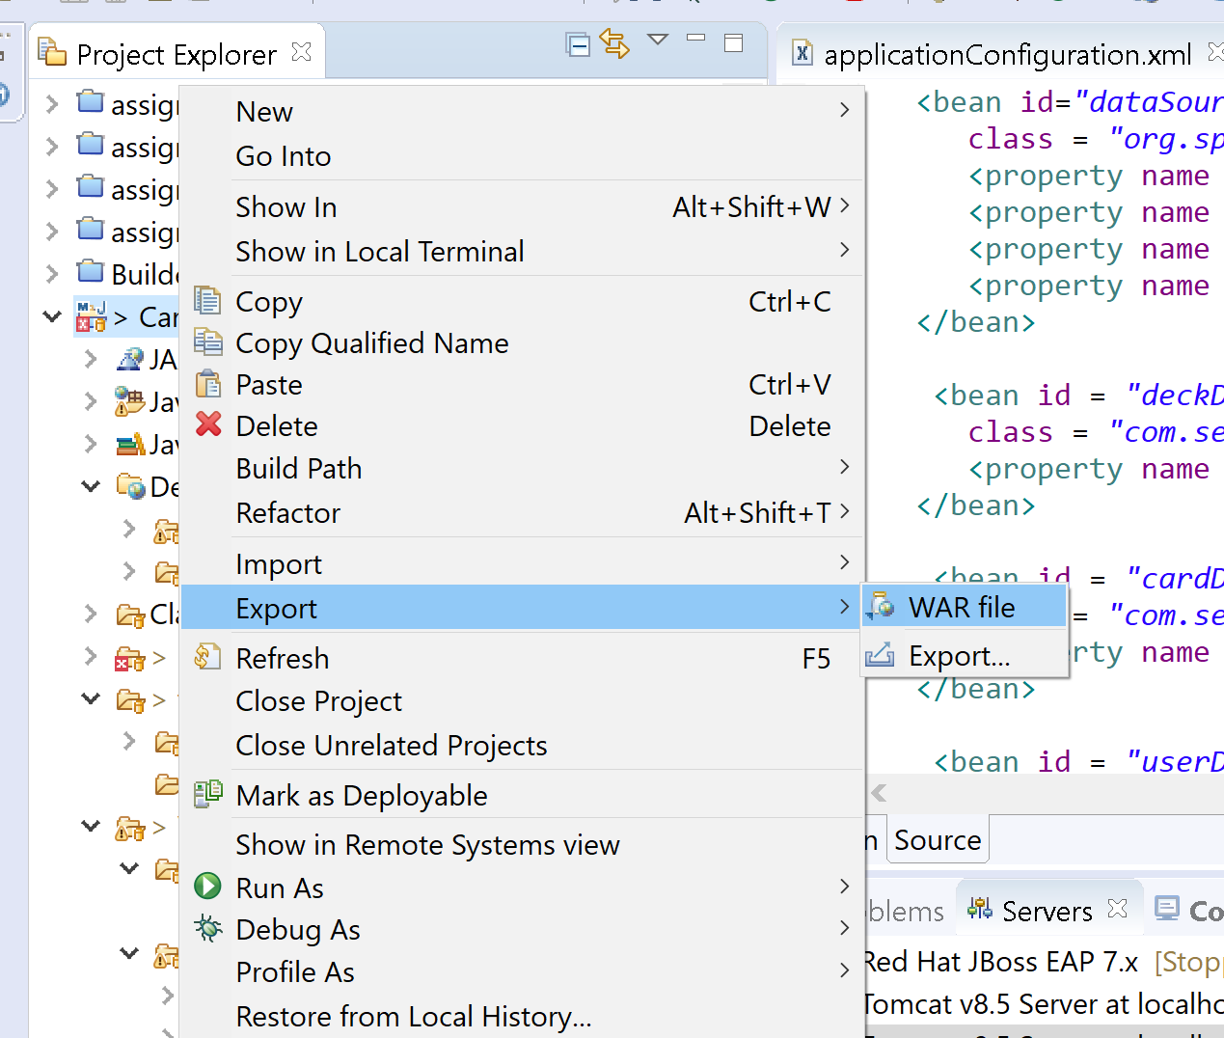
  + Make sure that it is optimized for the specific type of deployment and name it -> finish
  + 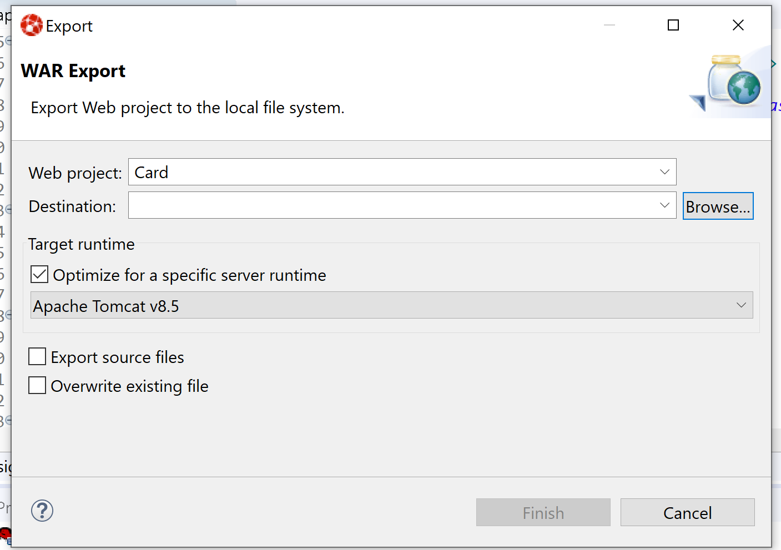

AWS Tomcat Setup:

* Navigate back to console
* Click Elastic beanstalk
* Create new application
  + 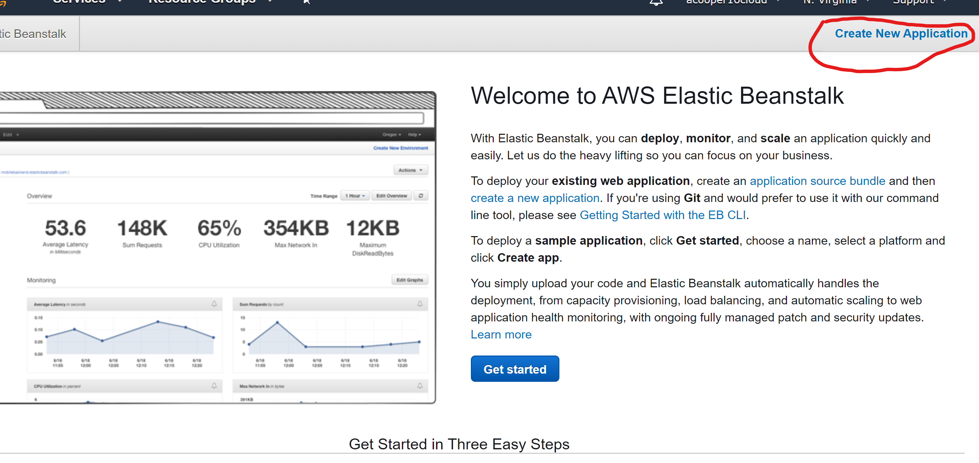
* 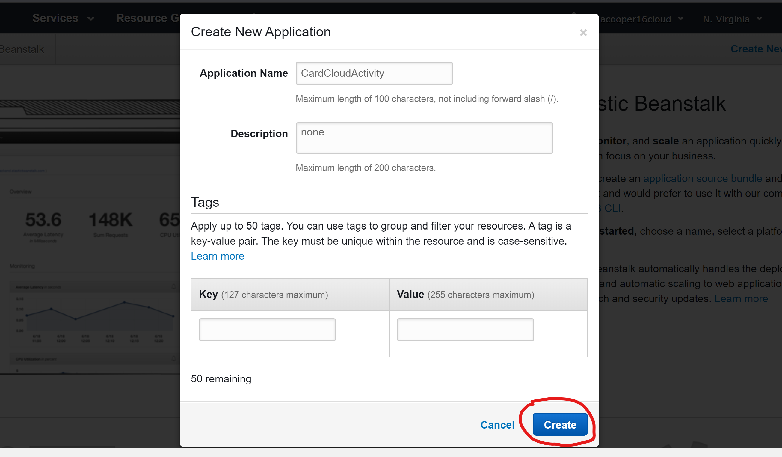
* Create an environment
* 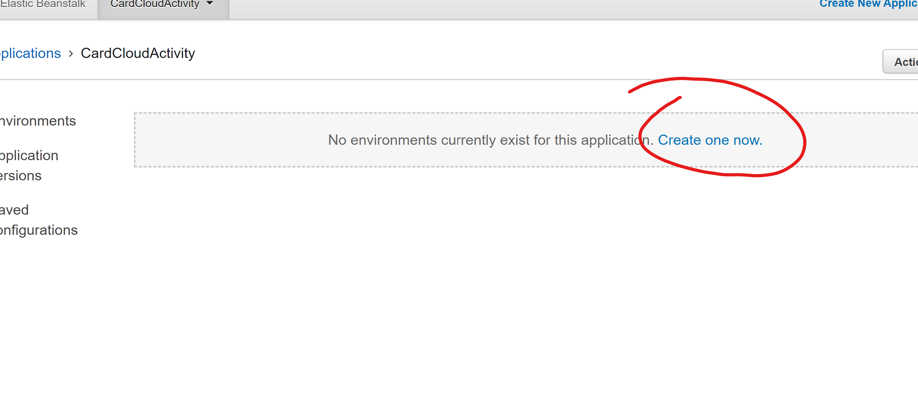
* Select Web server then press the select button
* 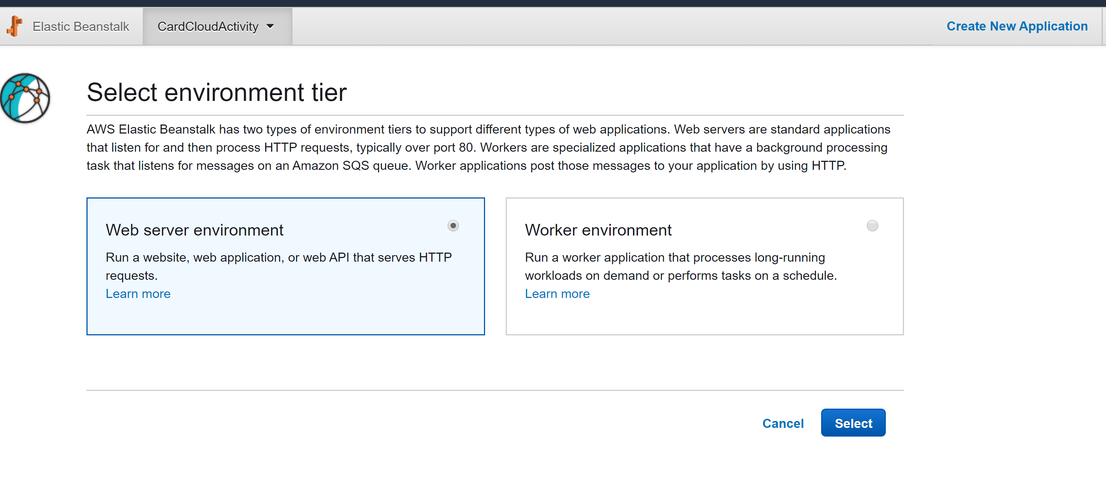
* Give it a name and set the preconfigured platform to tomcat
* 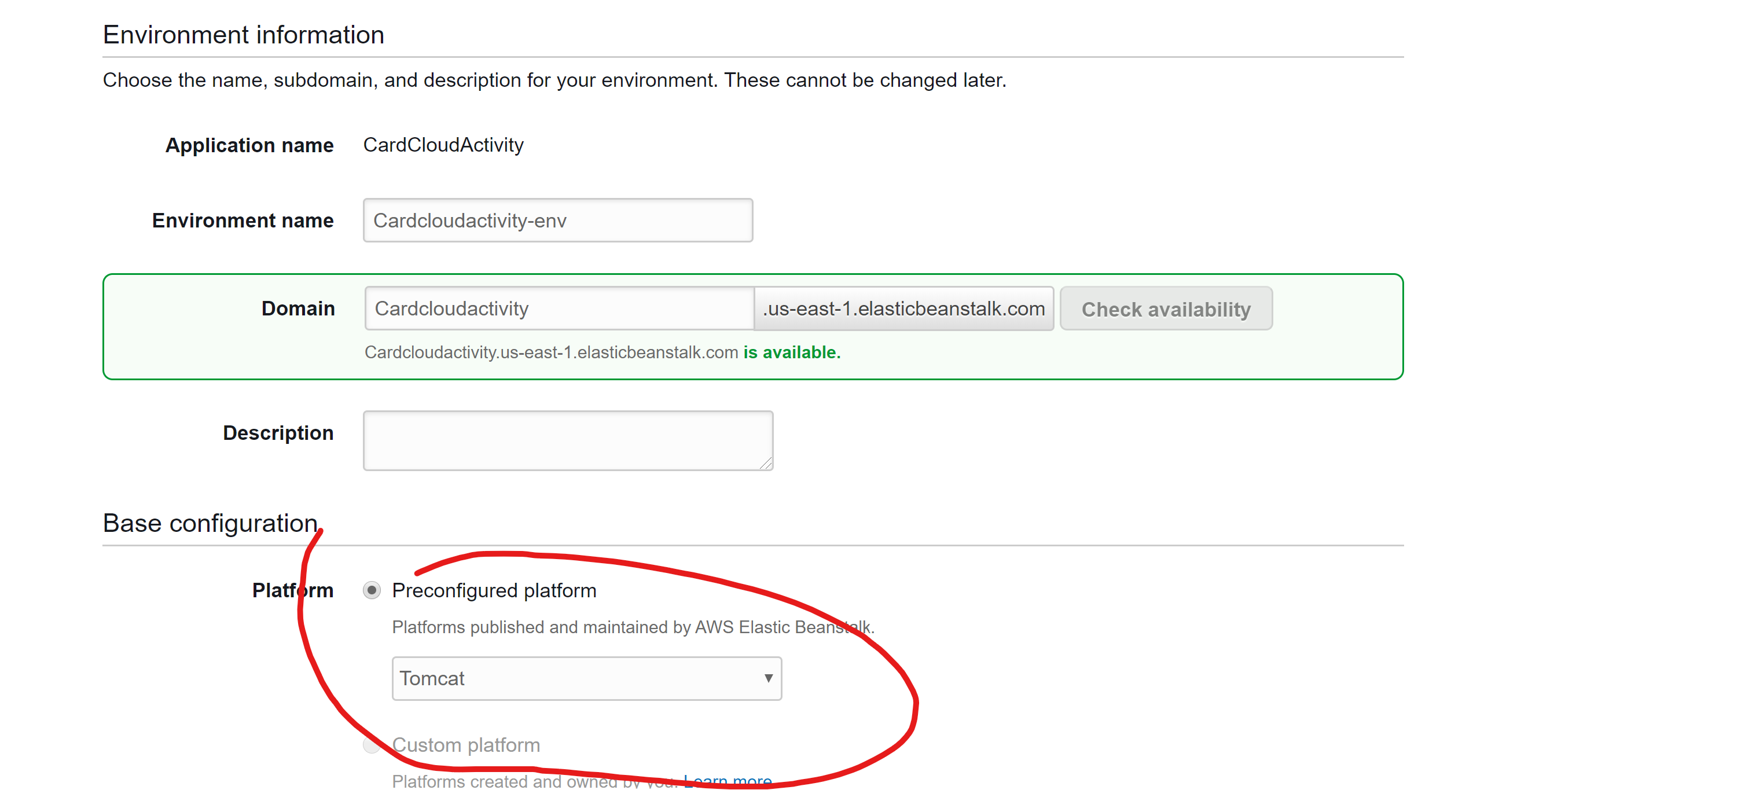
* Select Upload your code
  + 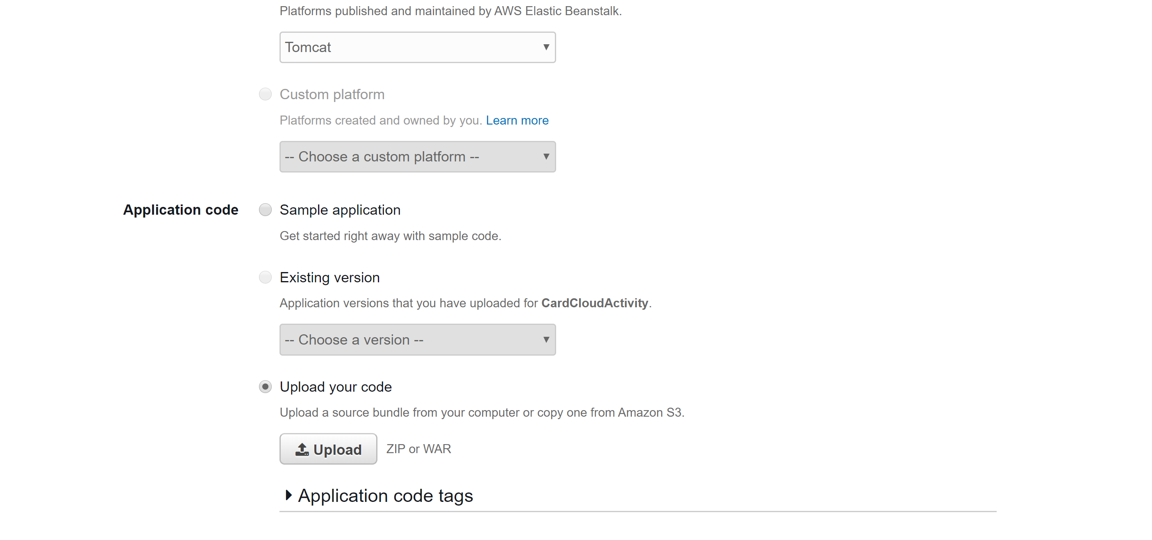
* 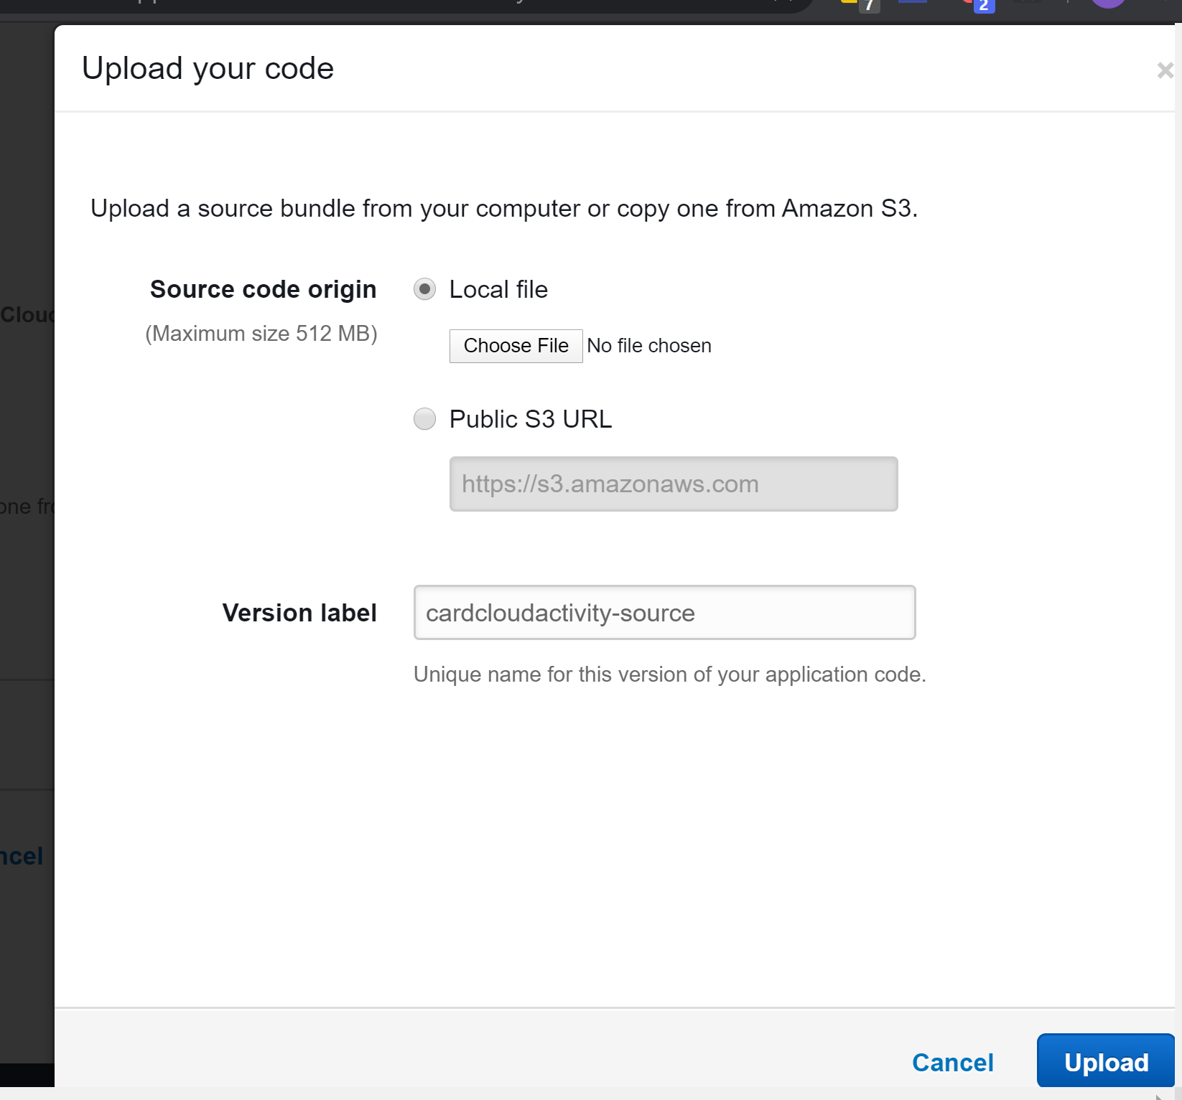
* Upload war file
* 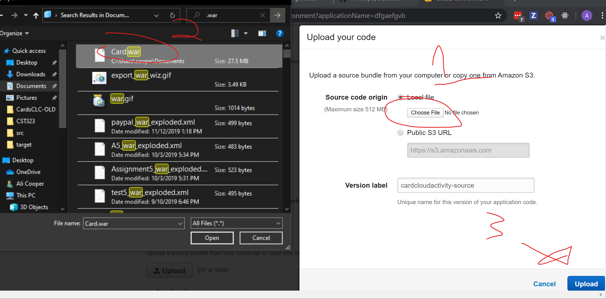
* Get war file from wherever it was generated to
  + “Documents/Card.war” for me
* Click create environment
  + 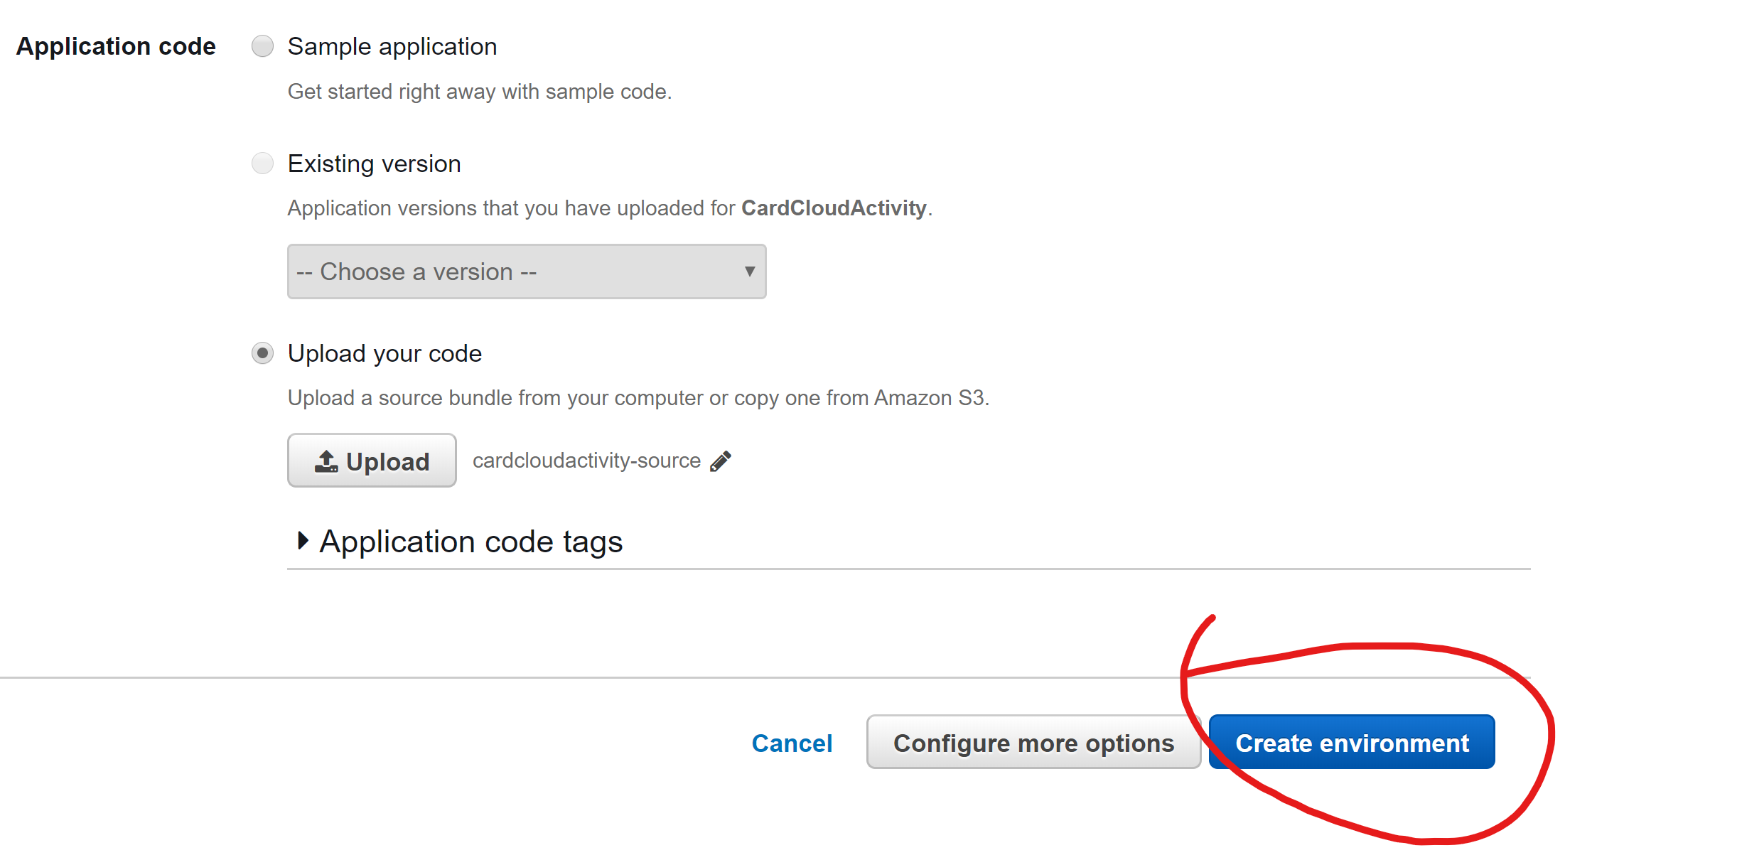
  + Test at <http://cardcloudactivity.us-east-1.elasticbeanstalk.com/>

GCloud Application Configuration:

- update pom (either use embedded or update dependencies according to what is mentioned in the dependencies section above)

- update applicationConfiguration.xml with credentials

- formatted like this:

jdbc:mysql://google/[SCHEMA]?socketFactory=com.google.cloud.sql.mysql.SocketFactory&amp;cloudSqlInstance=[PROJECT_NAME_ID]:[DB_REGION]:[DB_INSTANCE_NAME]

* + Move the /WebContent/WEB-INF/resources directory into /WebContent temporarily (for the deployment only)

GCloud Application Deployment:

* + Create/Use a git repo with a remote hosted on a site such as github for the project code.
  + Create new project and click “Get Started”
  + Set Language to Java
  + Set Environment to Standard
  + Activate cloud shell once the project has been created
  + Run “git clone <https://github.com/n4n0byte/cloudcard.git>” or the project name needed
  + Run “mv ~/<projectName>/WebContent/WEB-INF/resources ~/<projectName>/WebContent”
  + Run “mvn clean package appengine:run” (optional)
    - check to see if the application starts and runs properly (a link with the dev server address will popup in the console when it is started)
    - press ctrl+c 2-3x
  + mvn clean package appengine:deploy
  + Test at <https://testproject-268315.appspot.com/>

**Research Questions:**

Read the assigned textbook required readings for this topic. Let's say you decide to leverage (i.e., consume) a REST API that is published from a social media website, such as Facebook or Twitter. What are five relevant technical questions related to non-functional requirements and security that would you need to ask the vendor?

* + What expectations should I have with the availability of the service?
  + What sort of response times can I expect for both data intensive queries?
  + How does the API interact with various localizations?
  + What is the threat model used for the API?
  + What is the policy on breaking changes with the API?

Compare the cloud features of Amazon AWS and Google Cloud. Present at least 10 features, explaining how they are similar and/or different. Explain your rationale.

1. Event Logs
   1. Both Services offer event logs that allow users to monitor logs and http status codes in their consoles.
2. Server Technologies
   1. AWS offers its users a tomcat server, while google cloud also provides tomcat instances, we used a google app engine standard environment which uses Jetty.
3. Blockchain Services
   1. Google provides instances that come preconfigured to run various instances of blockchain service applications. AWS doesn’t seem to have a prebuilt equivalent.
4. Communication with MySQL DBs
   1. Google cloud uses a unix domain socket for deployed projects (given our standard environment configs) to communicate with the DB while AWS’s RDS instances allow for normal ip based connections.
5. Checking deployment health
   1. They both provide health monitoring for deployed applications
6. Console Comparison
   1. Both services provided a console that allowed for users to manage and create instances of various types. Google cloud also provides a cli environment with some standard linux commands available.
7. DB Security
   1. Google cloud’s DB has better out of the box security compared to AWS because it requires the user to explicitly allow an ip address to access it externally. RDS has no such requirement and anyone can access it assuming they bruteforce/know the credentials.
8. Application Security
   1. They both offer IAM services, which allow for highly customizable security specifications.
9. Budgets
   1. Both platforms allow users to create budgets so that services can shut off before they get charged more than what they were expecting.
10. Deployment History
    1. AWS’s Elastic Beanstalk Service has an application deployment history tracker. It allows for the application to be reverted to a known working state. Google cloud does not have this feature for the standard app engine environment.

Identify five technical or business limitations that could restrict an existing application from being deployed onto any of the Cloud Platforms that were utilized in Topic 3 or Topic 4. Explain your rationale

* + The migration could be too cost prohibitive
    - Companies could potentially loose too much money/customer trust in the downtime needed to migrate. Causing the company to go out of business.
  + It could require too many significant architectural/technology changes
    - A company could have an application that is dependent upon a technology that is unsupported by the cloud. This could mean that dependencies would need to be updated, which could require changes to source code to accommodate breaking changes.
  + There could be key components/integrations of an application that are not supported at all by a cloud service.
    - This would mean that it wouldn’t be possible to deploy the application at all.
  + The resource usage could be too cost prohibitive
    - Services that require high resource usage for long periods of time can cause cloud services to be unaffordable for that use case.
  + There could be legal compliance issues with using some of the cloud services
    - Some countries may not allow specific services, an example of this would be China, china blocks all google services. This means services such as google cloud and firebase are illegal to use and inaccessible there.

**General Technical Approach:**

Naming conventions:

* Grammar: Camel Case
  + Ex.
    - Class
      * Card
    - Interface
      * IdeckUpdater
    - Method
      * getCardById(int id)
    - Variable
      * Card currentCard
    - Views
      * Collection.jsp
      * URLs: Camel Case
  + Ex.
    - <Application Title>/myCollection/showDecks

Configuration:

* Java Based

Dependency Manager:

* Maven

CSS:

* Layout System: CSS Grid, Shadow DOM, CSS Variables
* Theming: Bootstrap

Database Technologies & Frameworks:

* MySQL
* Spring Data

Git:

* Git ignore: ide files.

**Key Technical Design Decisions:**

Decided to us CSS instead of Grid containers because the grid container would break the format of views

Decided to make home page display list of decks and user will be able to add a new deck or card from their

**Known Issues:**

Issues with Git; updates to project would not be pulled correctly.

**Risks:**

|  |  |  |
| --- | --- | --- |
| **Risk** | **Details** | **Countermeasures** |
| **Features of project is too ambitious** | Features such as the deck copy and or search filter will take too long to finish along side the main features of application. | Scale back some features of the project and add additional features when the core of the project is done. |
| **Personal Emergencies** | Team member has family or personal emergency like: ill, funeral, wedding, ect. and cant finish workload. | Allow team member too know as soon as possible so that work can be taken care of before Milestones are due. |
| **Internet Problems/Issues** | Internet at GCU down or under maintenance. Loud Cloud down | Work from another location or use a hotspot to submit work.  Email Professor work explaing that we cant upload to Loud Cloud |
| **Time management for tasks** | The estimated amount of time for particular tasks for the milestone taking longer than estimated. | Practice SCRUM so that the team can properly manage tasks as efficient as possible. |

**ER Diagram:**

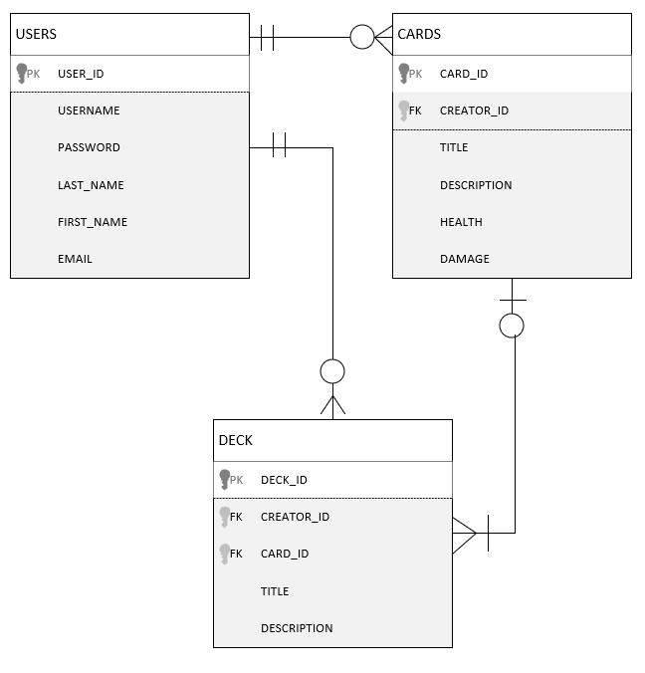

**DDL Scripts:**

N/A

**Sitemap Diagram:**

*.* 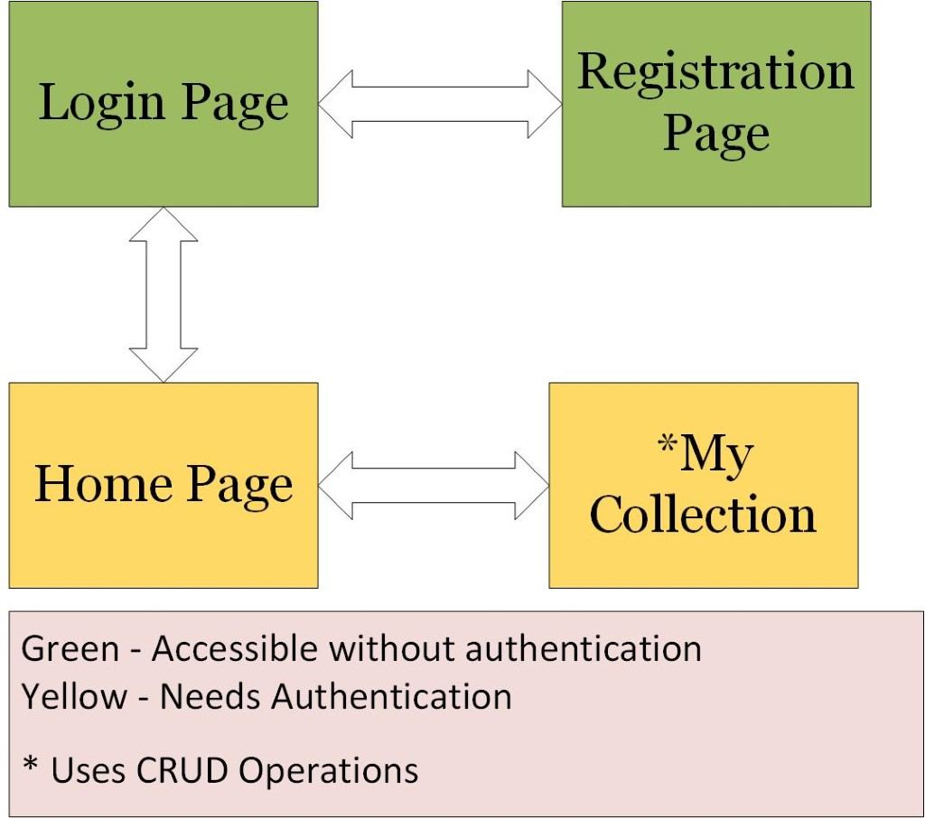

**User Interface Diagrams**

Index(may change index uri later)

**:** 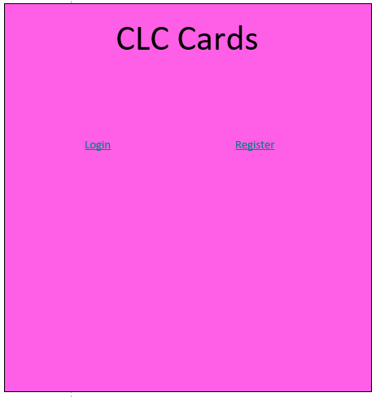

Login

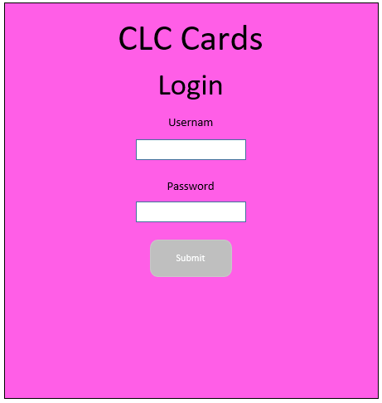

Registration

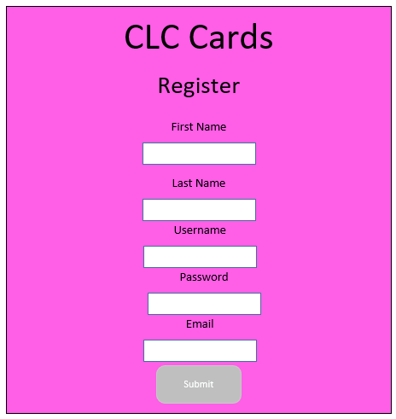

**New Deck**

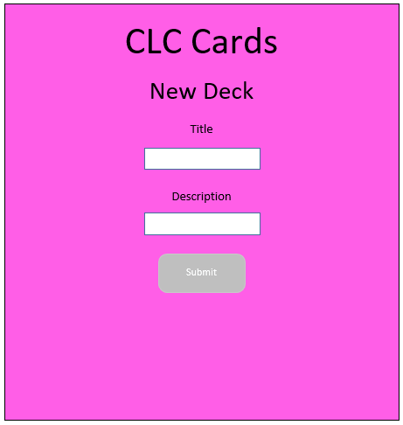

**AddCard**

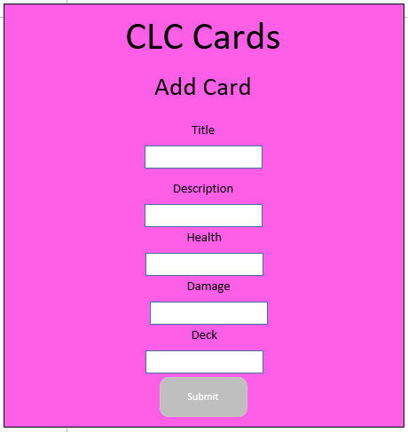

**Home**

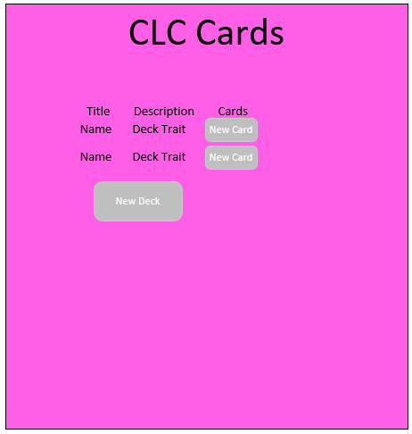

**Class Diagrams:**

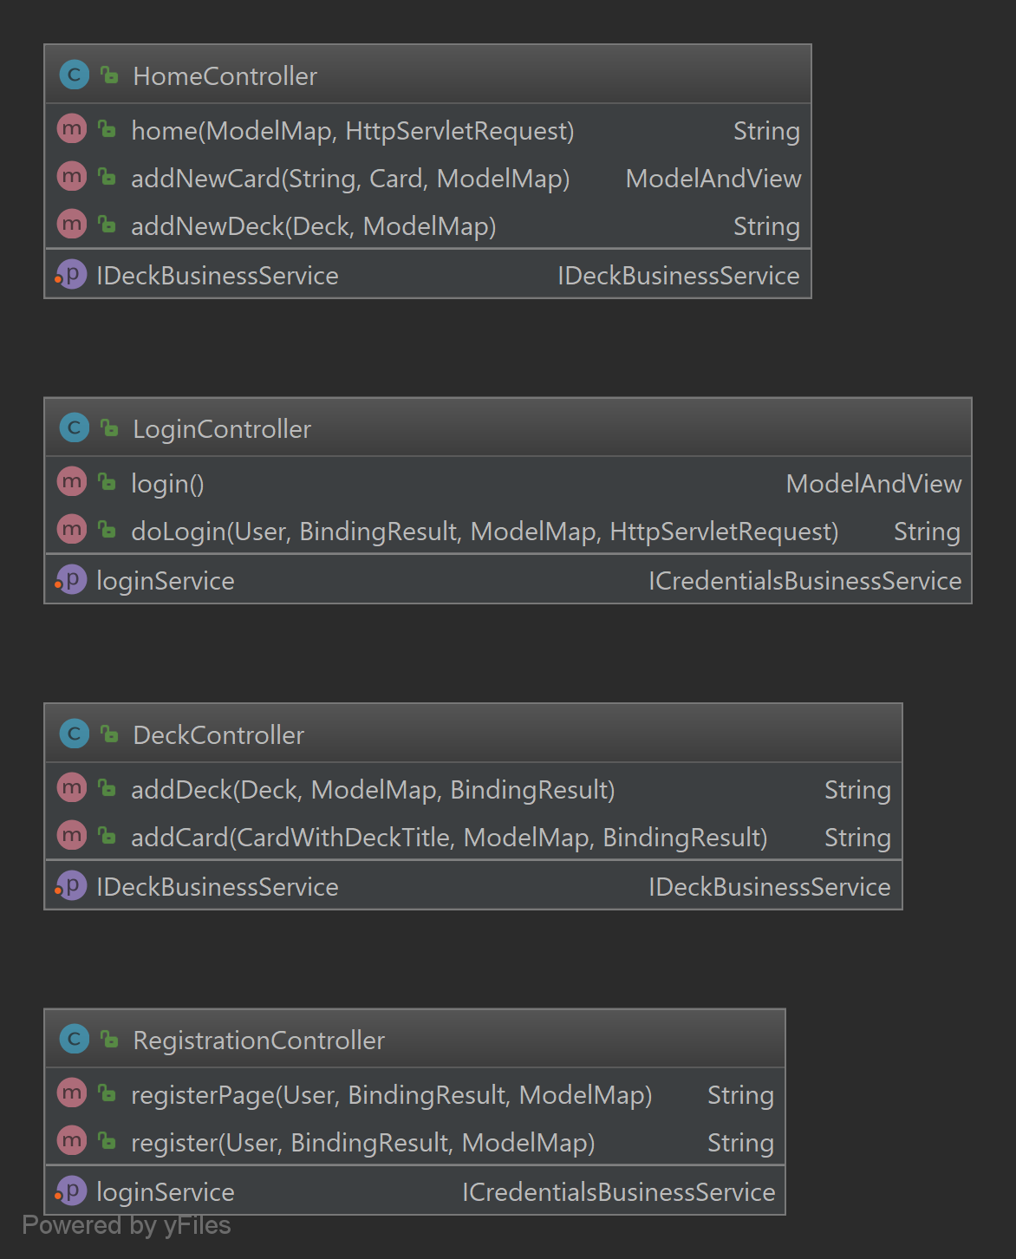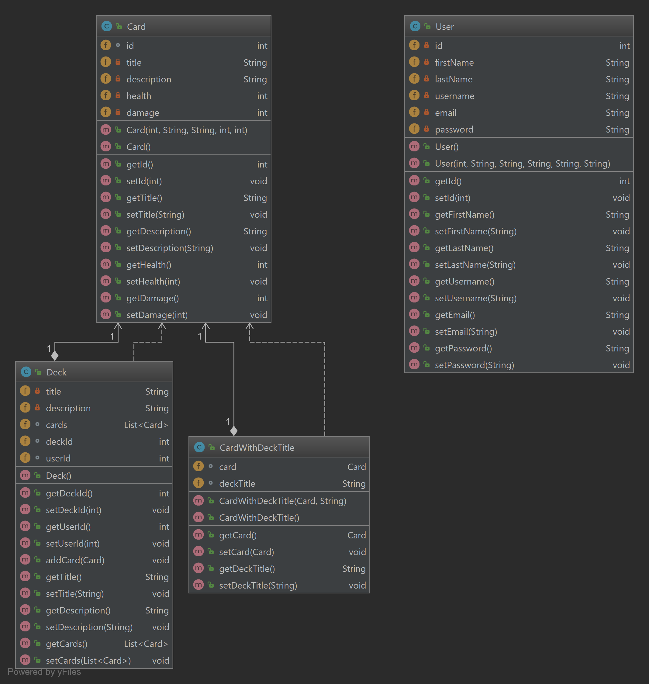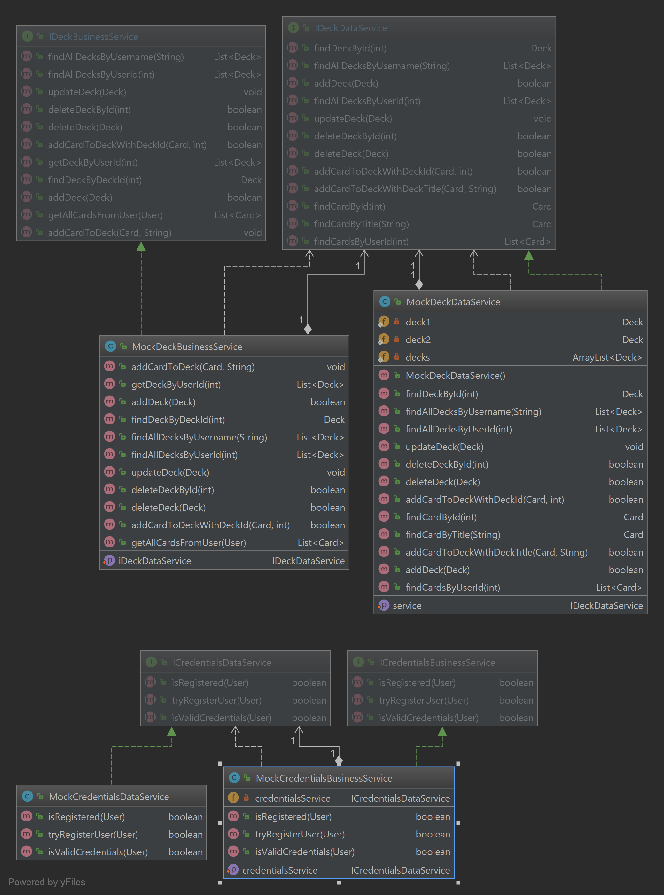

**Service API Design:**

*N/A*

**Security Design:**

*N/A*

**Other Documentation:**

N/A